Jonathan Rile
Partner: Alexander Botten
701085173
CpE 311 – Wednesday 5-7:50
2/5/14

Lab 4: Introduction to the SBC

Introduction
The purpose of this lab was to get used to using the Octagon 6040 Single-Board computer. In this lab, we learned how to write assembly programs, compile them using MASM 6.11, and then transferred to the single-board computer using HyperTerminal via a serial connection.

Exercise 1: Notepad++

Experiment
For this exercise, we simply had to open up Notepad++ and create a new assembly file. We were given the assembly code to use, shown below.
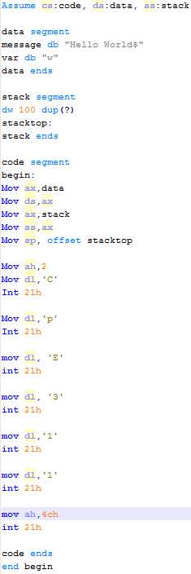
Certain lines in the code are required for the assembly program to run. The “user code” is in between mov sp, offset stacktop and code ends. After inputting the assembly code into Notepad++, we were to compile the file.

Results
We successfully inputted the code, and compiled it successfully. There was a warning, but the tutorial says to ignore it. A .exe file was then created in the same directory, which is what we will be running on the single-board computer.

Exercise 2: Transferring to the Octagon 6040

Experiment
The point of this exercise was to transfer our newly created executable to the Octagon 6040 and run it. What we had to do was turn the PC off, open HyperTerminal and create a new connection. We then connected using the COM1 port, set the baud rate to 9600, data bits to 8, parity to None, stop bits to 1, and flow control to none. In the HyperTerminal prompt, we then typed Transfer TEST.EXE. Even though our .exe was not named TEST.EXE, it does not matter. Using the HyperTerminal Transfer menu, we located our .exe and sent it using the 1k Xmodem protocol. After it was transferred, we simply typed TEST.EXE in the HyperTerminal and the program ran.

Results
The program successfully ran, and we saw “CpE 311” output through HyperTerminal.
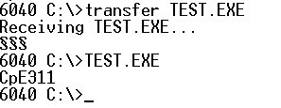

Exercise 3: 8086 Instruction Set

Experiment
The purpose of this exercise was to answer questions regarding assembly code.

Results/Questions
- Explain in detail how the MOV command functions. Write the code necessary to populate the CX register with 123₁₆ and the BX register with 83₁₆.
MOV functions by copying a byte from the source to the destination.
mov CX, 123
- Explain in detail how the ADD command functions. Write the code necessary to add the CX and BX registers together.
ADD functions by adding the source to the destination, overwriting the destination’s value with the sum.
add CX, BX – this is the same as saying CX = CX + BX
- In this line of code: “ADD BX, CX”, in which register would the sum be stored?
BX as stated above.
- Explain in detail how the JMP command works.
JMP simply jumps to the specified label. It acts like “GOTO” in the C language.
- What is the difference between the JNE and JE commands?
JNE = jump if not equal. JE = jump if equal.
- Explain in detail how the LOOP command functions. If the CX register is populated with 10 hex, how many times will the body of the loop execute?
Decrements CX and then loops back if CX is not equal to 0.
15 times, since CX is decremented first.
- Explain in detail how to use function 2 of INT 21h. Explain each line and its purpose. (Only 3 lines in total)
Function 2 writes a character to standard output using the interrupt function (whatever is in DL.)
mov ah, 2 – this tells interrupt to use function 2
mov dl, ‘C’ – this is the character that will be printed
int 21h – this calls the interrupt function, which then reads ah & dl and prints ‘C.’
- Explain in detail how to use function 4Ch of INT 21h. Explain each line and its purpose. (Only 2 lines in total)
Function 4ch terminates the program using the interrupt function.
mov ah, 4ch – this tells interrupt to use function 4ch when called.
int 21h – this calls the interrupt function, which reads ah, sees ‘4ch’ and terminates the program.
- Replace the lines of code within the rounded rectangular box of Fig. 2 with the following code:
Mov ah, 2
Mov dl, message
Int 21h
Mov si, offset message
abc:
Mov dl,[si]
Cmp dl,”$”
Je end_prog
Int 21h
Inc si
Jmp abc
End_prog:
Mov ah, 4ch
Int 21h
a) Explain the output. Why did is print the character ‘H’ twice?
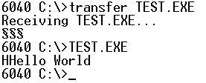
When mov dl, message is called the first time, it only stores one letter, not the entire string. So when int 21h is called, it is printing what is in dl, which is only one single character ‘H.’
b) Would the program work if you use
mov si, message
instead of
mov si, offset message
in the above program?
Why?
No, the program would not know to look in the stack. In fact, the program would not compile.

Exercise 4: The SBC

Experiment
This section is simply to let us learn more about the Octagon 6040.

Results/Questions
- What is the type of CPU and what is the clock speed?
Ali M6117 386SX. It has a clock speed of 40 MHz.
- What type of temporary storage device (RAM) is used? What size?
2 MB surface-mount fast page DRAM.
- What type of permanent storage device is used? What size?
1 MB flash with 512 KB available. A second SSD with 128 KB for storage.
- How many digital I/O lines are provided, and how are the digital I/O lines grouped? At 5V, how much current can each line sink or source?
24 lines of digital I/O are provided with 17 additional digital I/O lines accessed through LPT1. Groups of eight. 15 mA.
- What is the function of the Watch Dog timer?
If a program fails, it will perform a hardware reset. Guards from program crashes and processor lockups.
- What is the typical Watch Dog timer timeout value?
1.6 seconds.

Conclusion
This was a very useful lab, as the SBC’s will more than likely be used a lot in this class. It was important to get acquainted to not only the SBC, but HyperTerminal and Notepad++. Overall, I think this lab will prove to be very helpful.

